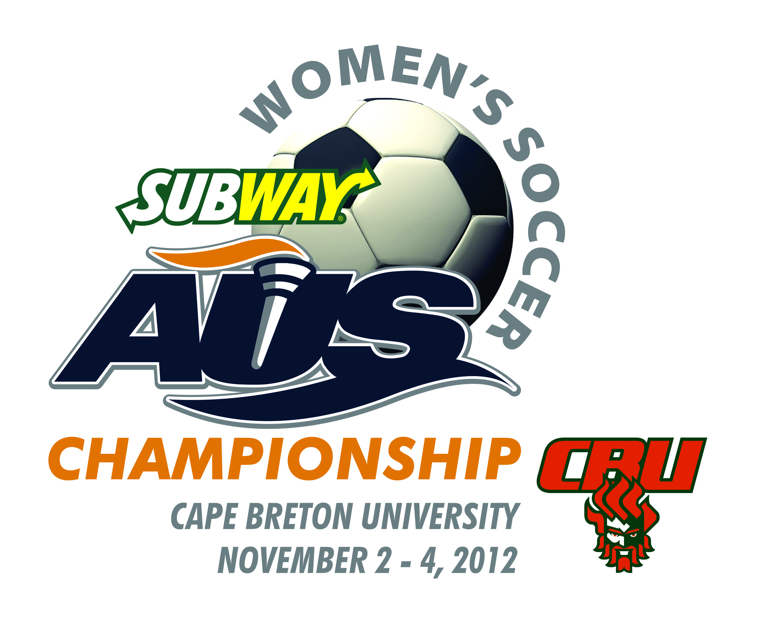

INFORMATION BULLETIN #3

Cape Breton University will host the 2012 Subway Atlantic University Sport Women’s Soccer Championship from November 2nd – 4th at Cape Breton Health Recreation Complex.

In preparation for this weekend, the organizing committee has been working hard to ensure that it will be a memorable event for all. Should you have any questions, please contact:

Carol Ann Sheppard at (902) 563-1277, carolann_sheppard@cbu.ca

HOST HOTEL
Rooms have been temporarily reserved at the Holiday Inn Sydney Waterfront, located at 300 Esplanade, Sydney, NS. The Holiday Inn Sydney Waterfront is an approximate 10-minute drive to the University. The rate of $109 (plus applicable taxes) per night has been negotiated for the teams. Teams are required to stay at this venue since the hotel is a major sponsor of AUS events. To book, please call (902) 562-7500 and indicate that you are with the AUS Women’s Soccer Championship. The rooms will be held at the above rate until October 26th.

PLEASE NOTE: Ten (10) NDD’s (non-smoking doubles) have been tentatively booked for each participating team. If you require additional rooms, there are no guarantees that you will get them; however, the Holiday Inn Sydney Waterfront will try to accommodate your request.

SCHEDULE
Friday, November 2 – Quarterfinals

Game 1 12:00 noon (#3) vs (#6)
Game 2 3:00 p.m. (#4) vs (#5)

Saturday, November 3 – Semi-Finals

Game 3 12:00 noon (#1) vs (lowest seeded remaining team)
Game 4 3:00 p.m. (#2) vs (highest seeded remaining team)

Sunday, November 4, Championship Game

Game 5 2:00 p.m. Winners of Games #3 & #4

AWARDS BANQUET
An “Awards Banquet” will be held on Thursday, November 1, 2012, at the Membertou Trade and Convention Centre, 50 Maillard St., Sydney. Doors will open at 6:15 p.m., with dinner beginning at 7:00 p.m. Tickets are $45.00 each and teams are requested to inform us of the number of tickets required by October 29th 12 NOON. Teams will be invoiced after the championship. Please email: carolann_sheppard@cbu.ca

If there are any food allergies or dietary concerns, please also note this in your banquet ticket numbers so the proper arrangements can be made. Also please note if you require any vegetarian meals.

In preparation for the Banquet, we would request that each team provide us with a jersey to display at the venue. For teams who don’t qualify, we will courier your jersey back once the event is over. Deadline for jersey submission is October 29th. Please send c/o Doug MacKenzie, Cape Breton University, Department of Athletics, PO Box 5300, Sydney, NS, B1P 6L2.

AWARDS & CEREMONIES
Following each game, a player of the game from each team will be selected. Winners will be asked to come forward to accept a gift while teams remain at their benches.

All Conference Awards will be announced the week prior to the event and recognized at the Tournament Banquet.

Following the Championship game the AUS Banner and AUS Trophy will be presented.

TICKETS AND PASSES
Team rosters will be used for determining the number of participant passes for each team. Additional tickets will be available at the regular cost. Passes should be worn at all times, unless the players are in uniform. Your cooperation is important to assist us with the security of this event.

Coaches of non-participating teams should contact John Ryan, Director of Athletics, at john_ryan@cbu.ca, to arrange for a tournament pass.

PASSES ARE NOT AVAILABLE TO THE GENERAL PUBLIC.

The following is a break-down of the ticket prices:

Adult $5.00/day
Students/Child (7-12)/Senior $4.00/day
CBU student with ID/Under 6 FREE

Please Note: AUS Media Passes and other passes will not be valid for this event. See ‘Media’ for further information.

VIDEO AND WEBCASTING
The organizing committee will be filming all matches and each coach will receive a copy of the video of their game. All games will be webcast at www.AUStv.ca.

HOSPITALITY
There will be a hospitality room at the Holiday Inn Sydney Waterfront for coaches, sponsors, and VIPS, which will be open on Friday and Saturday evening.

MEDIA
Media accreditation must be arranged through Doug MacKenzie. Email Doug at doug_mackenzie@cbu.ca.

PRACTICE TIMES

Practice times can be arranged at the CBHRC facility. Please contact Doug MacKenzie (doug_mackenzie@cbu.ca) to set up times. Teams are to provide their own practice balls.

TEAM ROOMS
Team rooms will be available on a per game basis and will be assigned upon arrival at each match.

HOME TEAM
The higher ranked team will be considered the home team, except when playing CBU.

REGISTRATION
Teams can check-in at the Holiday Inn Sydney Waterfront, Thursday, November 1, 2012. Tournament packs and participant passes will be given out at the conclusion of the Awards Banquet. NB: Tournament packs and passes will need to be signed for so please allow extra time at the conclusion of the banquet for distribution.

MEDICAL
There will be an Athletic Therapist and doctor available during the tournament.

Please bring the appropriate provincial medical numbers and medical insurance information for your players and staff in case physician or hospital services are needed during the tournament.

PARKING
There is a $1.00 parking charge per day to park in the University parking lot. There will be ample space available for buses to park after they drop off the players at the door.

LAUNDRY SERVICE
Cape Breton University is unable to provide laundry services. Ashby Laundromat, located 453 Whitney Ave, Sydney, is located five minutes from the Holiday Inn Sydney Waterfront.

HARRISS HALL (DINING)
CBU’s Harriss Hall is open for all visiting teams and officials. Harriss Hall offers an unlimited access all-you-care-to eat program. You pay per meal to enter the dining hall but once in you are free to eat as much or as little as you like. Prices: Breakfast $6.20; Lunch $8.80; Dinner $10.95. ALL are subject to HST. Visit their website at www.dineoncampus.ca/cbu

SPORTS INFORMATION REQUIREMENTS

The FTP site to be used for all photos (high resolution) is:

Server name: cbub2b
Login name: aus2012
Password: cbu$aus

Teams should login to their appropriate team folder to upload high resolution photos.

Photos: (please send as soon as possible)

Head and shoulder shots of all players, coaches and support staff
10 action shots
Team picture with left to right caption
Action shot of all graduating players
30-60 sec. video highlights of season

All Stars and Major Award Winners:
Action Shot
Brief write-up on each

Banquet: (please send by 12 NOON October 29, 2012)
Ticket quantity
Food allergies or dietary concerns
Send to: carolann_sheppard@cbu.ca

Other: (please send by October 22, 2012**)
Participants t-shirt sizes (NB: LIMIT 25 kit bags per team)
Send to: carolann_sheppard@cbu.ca
**If not received by the above date, the order will specify size large.

All sport information and team information should be submitted by as soon as possible to doug_mackenzie@cbu.ca

We do realize that tournament participants may not be confirmed; however, all teams should submit the required details to the host to enable adequate preparation time for the brochure and presentations.

THANK YOU FOR YOUR COOPERATION.

BEST OF LUCK.

SEE YOU AT THE CHAMPIONSHIP!!!

